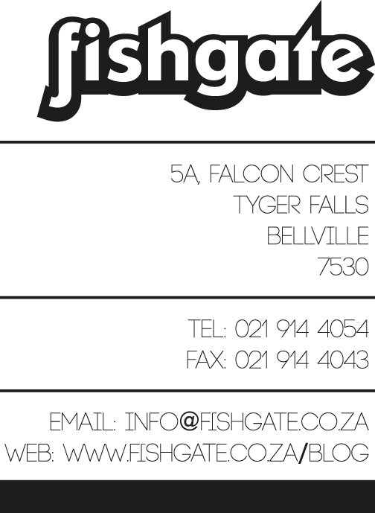

**Supplier Registration form – NON TRADE**

Please indicate if you are: A New Supplier

Amending Current Supplier details

____________________________________________________________________________________________________

**The following documentation is requested:**

|  |  |
| --- | --- |
| Original valid Tax Clearance Certificate |  |
| Copy of valid BEE Verification Certificate |  |

Please send documents per email to: [accounts@fishgate.co.za](mailto:accounts@fishgate.co.za). The original signed registration form and all required supporting documentation must also be send to: Fishgate Advertising

5 Falcon Crest, Tygerfalls, Bellville, Cape Town, 7550

____________________________________________________________________________________________________

Nature of the goods or services providing to Fishgate? ­­­­­­­­­­­­­­­­­­­­­­________________________________________________

**Contact information**

|  |  |  |  |  |  |
| --- | --- | --- | --- | --- | --- |
| **Trading Name** |  | | | | |
| **Registered Name** |  | | | | |
| **Registration Number** |  | | | | |
| **Legal Structure** | Company | Closed Corp | Sole Proprietor | | Partnership |
| **VAT Registration Number** |  | | | | |
| **Country** |  | | | | |
| **Postal Address** |  | | | | |
| **City** |  | | | | |
| **Province** |  | | | | |
| **Physical Address** |  | | | | |
| **Telephone** | ( ) | | Email: |  | |



|  |  |  |  |
| --- | --- | --- | --- |
|  | **Name** | **Contact number**  **Office and Cell:** | **E-mail** |
| **Account Liaison**  **(will receive remittance)** |  |  |  |
| **Financial Manager** |  |  |  |
| **Sales Liaison**  **(Will receive purchase orders)** |  |  |  |
| **Relationship Manager** |  |  |  |

Payment details – strictly no third party payments allowed

|  |  |
| --- | --- |
| **Bank Name** |  |
| **Branch Sort Code** |  |
| **Account number** |  |
| **Account name** |  |

**Please take note of Fishgates’ standard financial terms and conditions:**

* Suppliers must ensure their invoices comply with SARS legislation.
* Invoicing Fishgate Advertising:
  + when invoicing a Fishgate Advertising Purchase Order, tax invoices must be invoiced to Fishgate Advertising cc, VAT registration number: 4620225989
  + Invoices must be emailed to [accounts@fishgate.co.za](mailto:accounts@fishgate.co.za) to ensure payment.
  + Invoices are to be send to Fishgate on or before the 25th of every month, or the closest working day before.
* No goods or services may be delivered without a Fishgate system generated Purchase Order being provided prior to such delivery.
* Only invoices reflecting a Fishgate system generated Purchase Order number will be honoured.
* Each invoice must carry a unique serial invoice number. Repeating invoice numbers, even in different fiscal years, will not be accepted.
* Invoices with incorrect and/or incomplete data, will not be processed until corrected and/or completed by you and initial payment terms will cease to apply.
* Manual changes to invoices will not be accepted.

**Acknowledgement**

I/We the Supplier representative/s warrant that all information contained in this document is true and correct and that I/we am/are duly authorized to sign.

For and on behalf of the supplier, he/she being duly authorized thereto:

|  |  |  |  |
| --- | --- | --- | --- |
| Name |  | | |
| Designation |  | | |
| Signature |  | Date |  |